Title of the contribution

M. Rossi¹, P.Parker²,...
(presenting author underlined)
¹ Affiliation1..., Address, Country
² Affiliation2..., Address, Country
email of the presenting author

Abstract

- Abstract maximum length: 1 page (if figures included – maximum 2 pages)
- Please submit the Abstract as a doc/docx and pdf file
- Authors must indicate ORCID ID (as given in fusnote) of the authors and corresponding authors which are the active researchers in the Republic of Serbia.

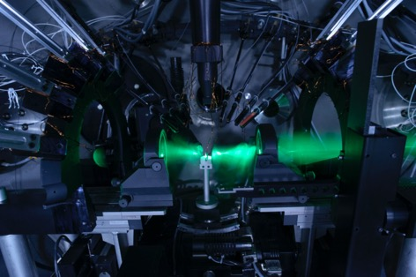
Figure 1. The caption of the figure.

Acknowledgements
The acknowledgements.

References
1. First reference
2. Second reference

